**Installing Visual Paradigm**

Click on this link <https://ap.visual-paradigm.com/city-university-london> and you will see a page something like this –

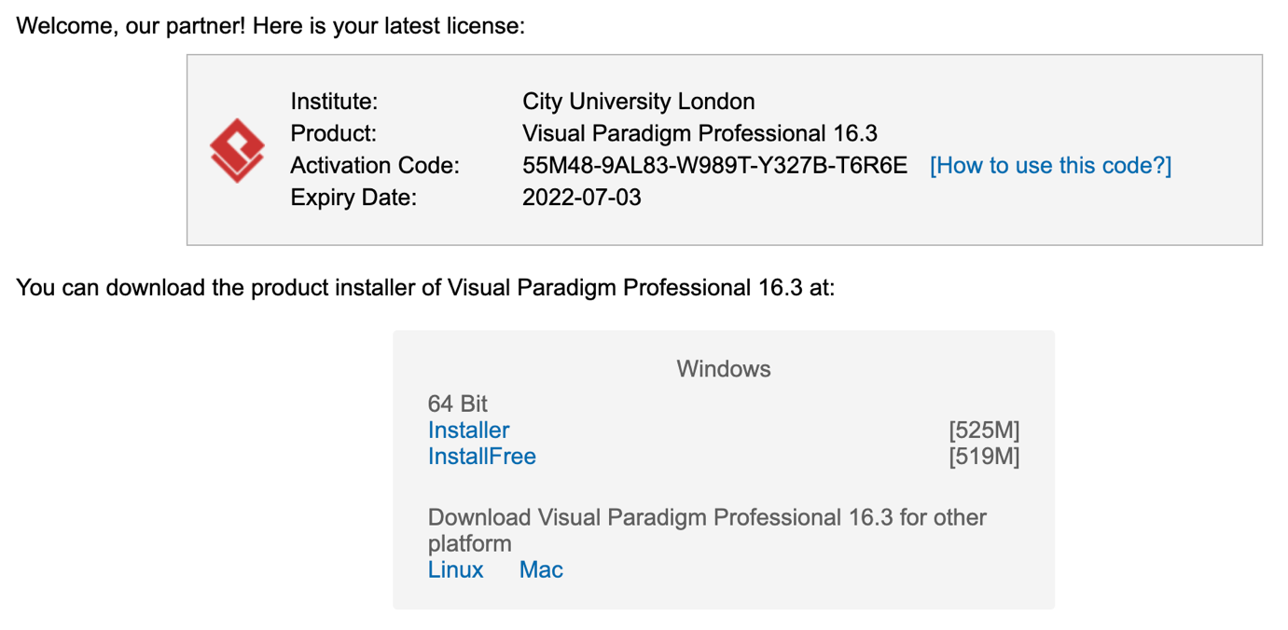

Download the appropriate version of **Visual Paradigm Professional 16.3** for your operating system. NB you must install release 16.3 to be able to use the University academic license key.

Click on the link [How to use this code?] next to the Activation code and follow the instructions there for installing and **Activating Visual Paradigm with Academic License. NB** To activate the software you will need the activation code from the webpage (not the one above) and you must use your City University email address for requesting the validation code.

Run Visual Paradigm and you will get an opening screen like this.

